Prepositions
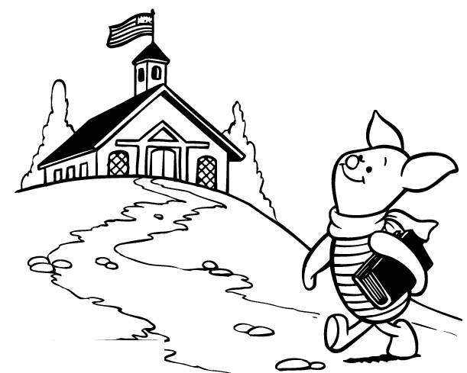
To
A preposition is a word that shows

___________________________________

___________________________________

Prepositions often locate something in

_______________ or ________________

A prepositional phrase is ___________________________________

Using prepositional phrases will help your writing be more _________

and _____________.

Prepositions ______________ require a comma before or after them.

Here are some common prepositions (there are many more!):

aboard
about
above
across
after
against
along
amid
among
around
as
at
before
behind
below
beneath
beside
besides
between
beyond
by
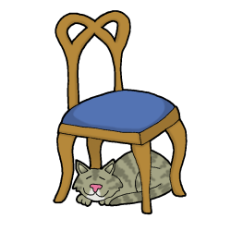
despite
down
during
except
for
from
in
Under

in front of
inside
instead of
into
like
near
next to
of
off
on
on top of
onto
out of
outside
over
since
than
through
throughout
till
to
toward
under
underneath
until
up
upon
versus
via
with
within
without
according to
because of
by way of
in addition to
in front of
in place of
in regard to
in spite of
instead of
on account of
out of

