Subordinating conjunctions

What is a conjunction?

The FANBOYS words are __________________________ conjunctions. We can use them to

_________________________________________________________________________________________________

These conjunctions give roughly _________________________ weight to each part of the new, combined sentence.

A subordinating conjunction is used to introduce a _____________________________________

Using a subordinating conjunction to begin a phrase will make a reader want

______________________________________________________________ to complete the thought.

When a sentence starts with a subordinate conjunction, you must ____________________

_________________________________________________________________________________________________

If a subordinating conjunction appears in the middle of a sentence, ____________________

_________________________________________________________________________________________________

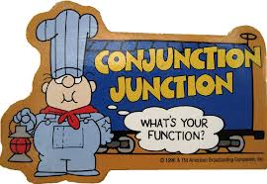
Time | Cause/Effect | Condition | Contrast

Write three sentences using the coordinating conjunction at the beginning:

1.

2.

3.

Write three sentences using the coordinating conjunction in the middle.

4.

5.

6.

