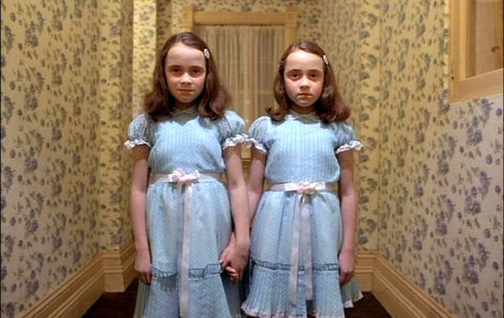
Evil Twins

Its – ______________________ form of “it”
Example sentence: ______________________________________________________
____________________________________________________________________________
It’s – ______________________ of “it is”
Example sentence: ______________________________________________________
____________________________________________________________________________

They’re – contraction of ______________________
Example sentence: ______________________________________________________
____________________________________________________________________________
Their – possessive form of ______________________
Example sentence: ______________________________________________________
____________________________________________________________________________
There – ______________________
Example sentence: ______________________________________________________
____________________________________________________________________________

You’re – ______________________ of “you are”
Example sentence: ______________________________________________________
____________________________________________________________________________
Your – possessive form of ______________________
Example sentence: ______________________________________________________
____________________________________________________________________________

To – shows ______________________ or ______________________
Example sentence: ______________________________________________________
____________________________________________________________________________
Too – ______________________ or ______________________
Example sentence: ______________________________________________________
____________________________________________________________________________
Two – ______________________ between one and three
Example sentence: ______________________________________________________
____________________________________________________________________________

